StockPulse Command Center
Make.com | Shopify/WooCommerce | Airtable/SmartSuite | Google Sheets | OpenAI/Claude | Slack | Gmail | Google Drive | ERP/API | Webhooks

Project Overview
Built an automated multi location inventory and replenishment management system for preventing stockouts, reducing overstock, and improving warehouse inventory decisions.
The workflow takes new sales orders and automatically updates inventory, calculates stock health, predicts replenishment needs, manages warehouse transfers, creates supplier orders, tracks deliveries, and monitors slow moving inventory.
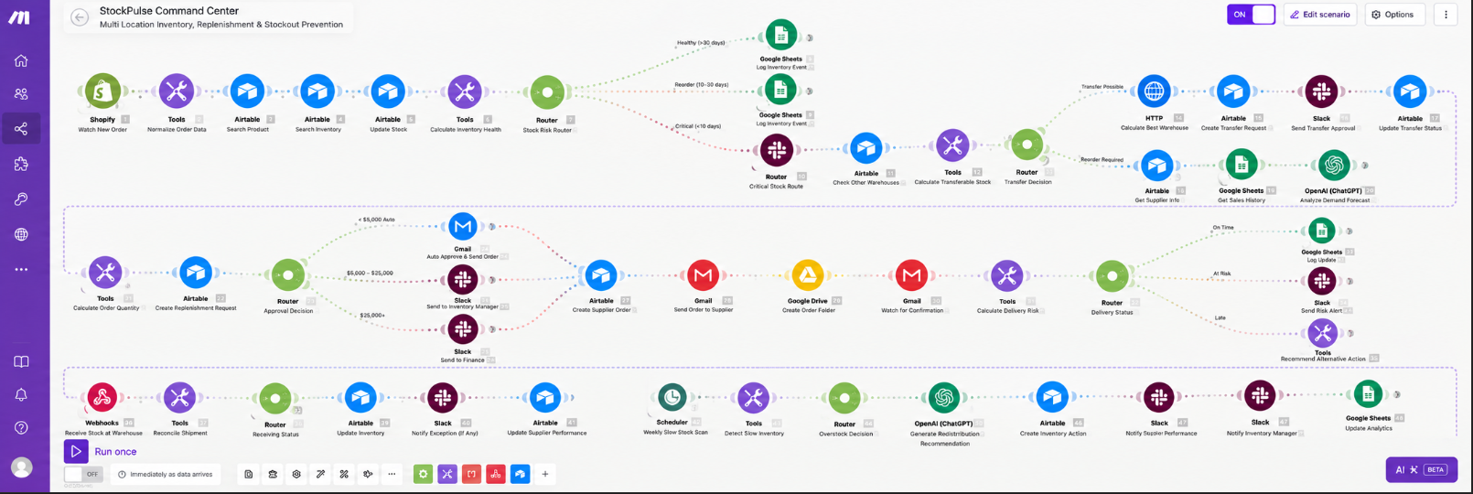
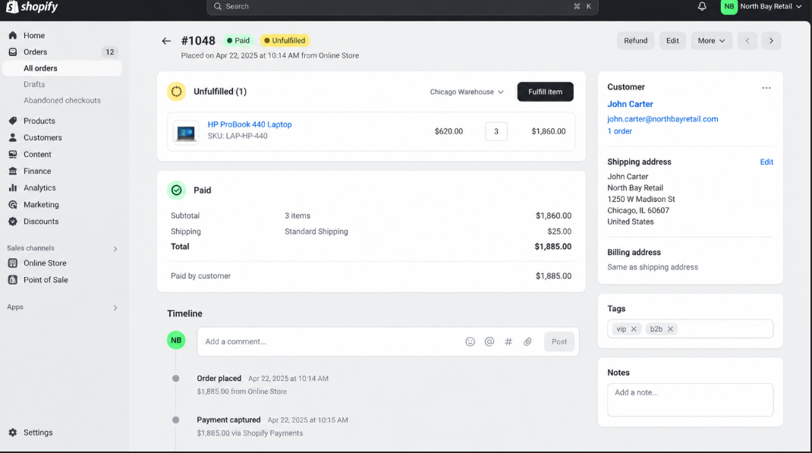
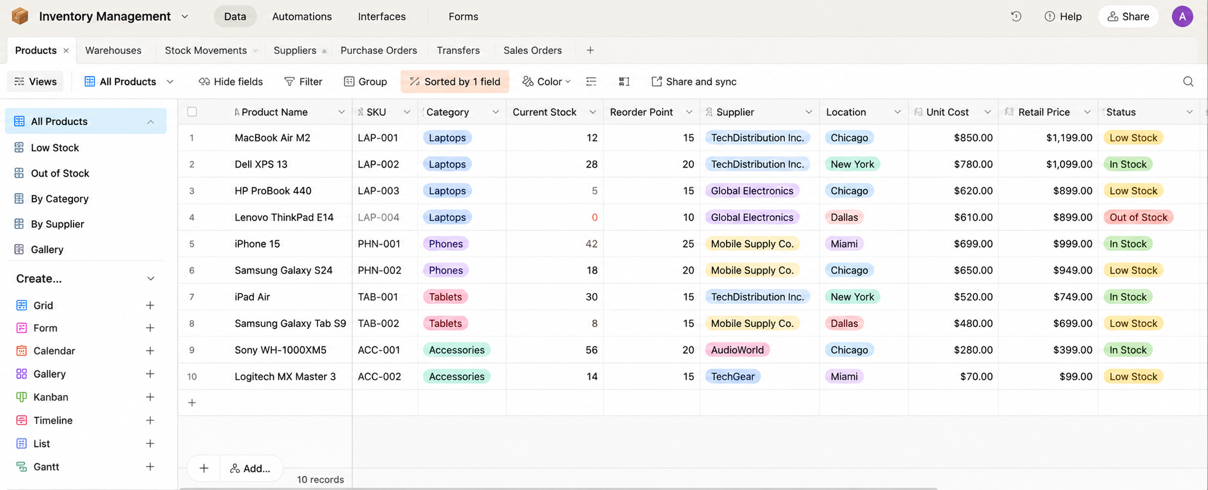
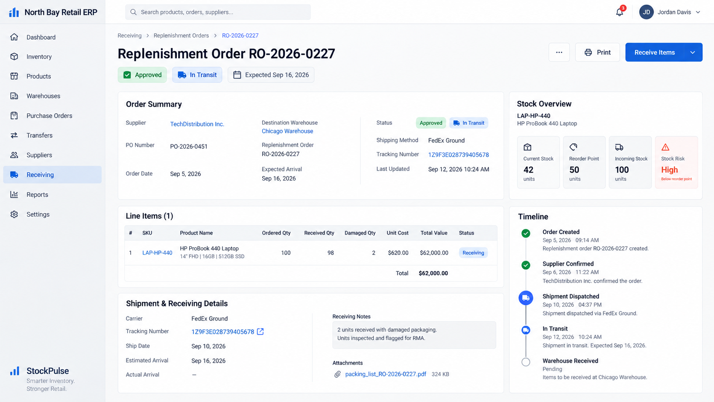

Workflow
The system:
- Receives new sales orders from Shopify or WooCommerce
- Normalizes order data from different sales channels
- Finds product and warehouse inventory records automatically
- Updates available stock after every completed sale
- Calculates inventory health, daily demand, and estimated days remaining
- Routes products based on healthy, reorder, critical, or out of stock conditions
- Logs inventory events and stock risk data in Google Sheets
- Searches other warehouses when inventory becomes critically low
- Calculates transferable stock without affecting source warehouse safety levels
- Selects the most suitable warehouse for internal stock transfers
- Creates and tracks warehouse transfer requests automatically
- Sends stock transfer approvals through Slack
- Retrieves supplier information when external replenishment is required
- Analyzes historical sales and demand trends
- Generates demand forecasts and stockout probability
- Calculates recommended reorder quantities using safety stock, lead time, MOQ, and incoming inventory
- Creates replenishment requests automatically
- Routes high value replenishment orders for manager and finance approval
- Creates supplier replenishment orders after approval
- Sends confirmed stock orders to suppliers through Gmail
- Creates Google Drive folders for supplier and shipment documentation
- Receives supplier confirmations and expected delivery information
- Calculates delivery risk against projected stockout dates
- Generates alternative inventory actions when supplier deliveries are delayed
- Sends critical stockout alerts to the operations team
- Reconciles received stock against supplier orders
- Updates warehouse inventory after successful receiving
- Detects damaged, partial, or incorrect deliveries
- Updates supplier performance using delivery and order accuracy data
- Scans inventory weekly for slow moving, excess, and dead stock
- Generates redistribution recommendations across warehouse locations
- Updates inventory analytics and operational reporting automatically

Branding & Templates
The workflow uses predefined replenishment, transfer, supplier communication, and inventory alert templates.
Each template controls:
- Stock transfer requests
- Replenishment approvals
- Supplier order communication
- Inventory risk alerts
- Warehouse receiving notifications
This keeps inventory operations consistent across different warehouses, products, suppliers, and sales channels.

Content Management
Airtable or SmartSuite acts as the central inventory, supplier, warehouse, transfer, and replenishment tracking system.
Each inventory record is updated with:
- Current stock
- Reorder point
- Stock risk
- Warehouse location
- Supplier information
- Transfer status
- Replenishment status
- Incoming inventory
- Supplier performance
- Inventory health

Technology
- Make.com
- Shopify/WooCommerce
- Airtable/SmartSuite
- Google Sheets
- OpenAI/Claude
- Slack
- Gmail
- Google Drive
- ERP/API
- Webhooks

Result
A complete automated inventory management pipeline that turns every sales transaction into an updated, monitored, forecasted, replenished, and optimized inventory operation without requiring teams to manually track stock across multiple warehouses.
The system also keeps inventory levels, warehouse transfers, supplier orders, delivery risks, slow moving stock, supplier performance, and stock analytics organized in one workflow.

